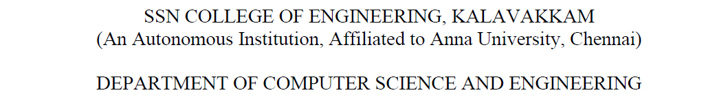
NETWORKS LAB
EXERCISE 8

Name: Jayannthan P T
Dept: CSE ‘A’
Roll No.: 205001049

Study of Network Simulator NS2

Screenshots:

